FESTIVAL EVENT REGISTRATION SYSTEM

TABLE OF CONTENTS:

1.ABSTRACT
2.INTRODUCTION
3.LITERATURE SURVEY
4.REQUIRMENT SPECIFICATION
5.ARCHITECTURE DESIGN
6.CONCLUSION AND FUTURE WORK
7.REFERENCES

ABSTRACT

In Festival Event Registration System, we primarily focus on developing an web application. Now-a-days, we have seen schools, colleges etc.., are conducting many events. So many people are interested to participate in those events. Sometimes, it is difficult for the participant to fill the details manually as well as to store the details of all the participants manually for the people who are conducting events. To avoid this problem, we bought our application into existence to make the work simple for both the event holders and participants. So that the participant can register and unregister for the events and also perform other operations like update profile, change password etc.., In this project, we are using high-end technologies like Spring MVC Framework, Hibernate, HTML5 , CSS3, JAVA SCRIPT etc..,

INTRODUCTION

Modules of this Project:

We are using Five Modules in this Festival Event Registration System. They are:
- Registration Module:
The Participants can register the events through this registration module. After submit the register these details will store into the database.

- Login Module: The participants should login into the portal to participate in the events.

- Update Module:
If they want to update the details of the participants they should go to the update module.

- Event Module:
All the event details are available in this event module. If they want to change the event they can logout and they can join in any other event. But, the participants should not participate in the already participated event.

- Change Password Module:
If they want to change the password information, they can change in this change password module.

In this way, the participants can easily handle all the situations easily in this festival event registration system.
We are using the technologies in this project are Spring MVC Framework and Hibernate as the Back-end Technologies and the HTML5,CSS3 and JavaScript as the Front-end Technologies.
So, through this Festival Event Registration System the participants can easily register the events and they can participate in the events easily. This is the Brief Hierarchy of the Festival Event Registration System.

LITERATURE SURVEY
Event Management System
The event management system is an online event management system software project that serves the functionality of an event manager. The system allow registered user login and new user are allowed to register on the application. The system helps in the management of events, users and the aspects related to them. This proposed to be a web application. The project provides most of the basic functionality required for an event type e.g. [Marriage, Dance Show Birthday party etc.], the system then allows the user to select date and time of event, place and the event equipment. All the data is logged in the database and the user is given a receipt number for his booking. The data is then sent to administrator (website owner) and they may interact with the client as per his requirement. Keywords: User, Admin, Events, Book, Event Management, Database.
REQUIREMENT SPECIFICATION
Software Requirement Specification:
This Software Requirements Specification (SRS) document is intended to give a complete overview of Festival Event Registration System Project (working title), including the user interface and Event organization. The SRS document details all features upon which FERS have currently decided with reference to the manner and importance of their implementation.

Product Perspective:
This product and application is newer which provides the user a new utility in their role as a visitor. The people should register in the page so that they can log in to the page. The users who will use this application, they will get the details of the upcoming technical events by just logging to the application and checking out the events and getting registered to the events.
Product Features
Functionality
The invention satisfies the foregoing needs and avoids the drawbacks and limitations and frustrations of the prior art, and provides a better, more timely and effective process of communication to schedule and coordinate events by utilizing Internet-based application.
This product contains three major Users. First the admin will allow the user for accessing this application by giving the permission rights and access control. Second the Event organizers who will login and list the events in the database. And third The End User i.e. visitor, they can see the list of the events and get register to the required event.
Uses and Characteristic:
Admin:
The Admin will have all the access to this product. The Admin will provide the access permission to the users which are students and Colleges. The admin can also delete or discard the unwanted events reported as spam. They also manage the database like deleting the past events.

Event:
The list of all the available events will be provide and the place where the event i held will be given. When the visitor wants to register to the required events he will provided with the available seats in the events.
Visitor:
The visitor are the end-user entity, they will be having the access rights to see the event format. And register their new account providing their basic details.

Other Non-Functional Requirements
Performance Requirements:
The system needs to be reliable. If unable to process the request then appropriate error message. WebPages are loaded within few seconds.
Safety Requirements:
The details need to be maintained properly. Users must be authenticated. The database must be kept backed up.
Security Requirements:
After entering the password and user id the user can access the profile. The details of user must be safe and secure.

ARCHITECTURE DESIGN

USECASE DIAGRAM :

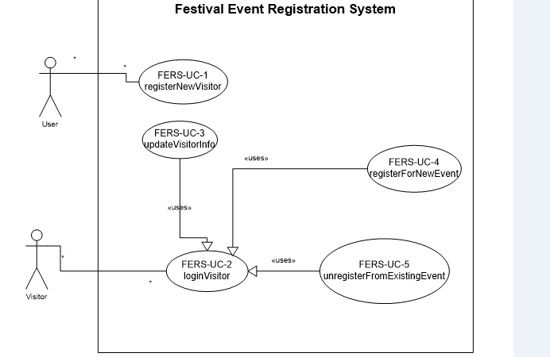

SEQUENCE DIAGRAMS :

REGISTER NEW VISITOR
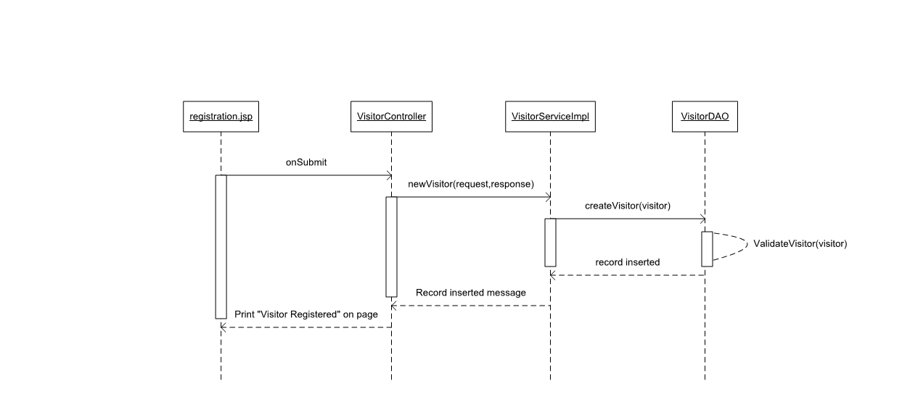

LOGIN VISITOR

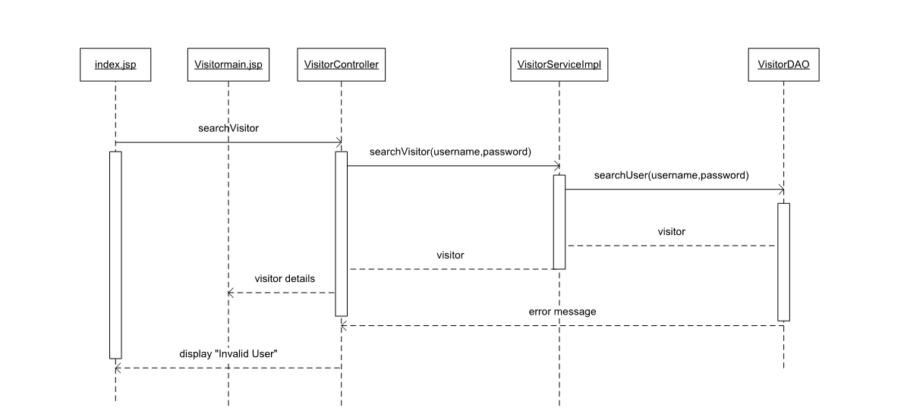

UPDATE VISITOR

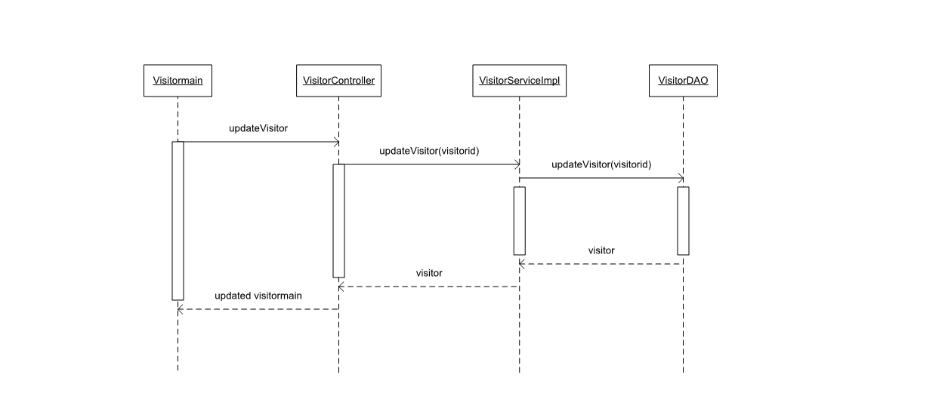

REGISTER FOR NEW EVENT

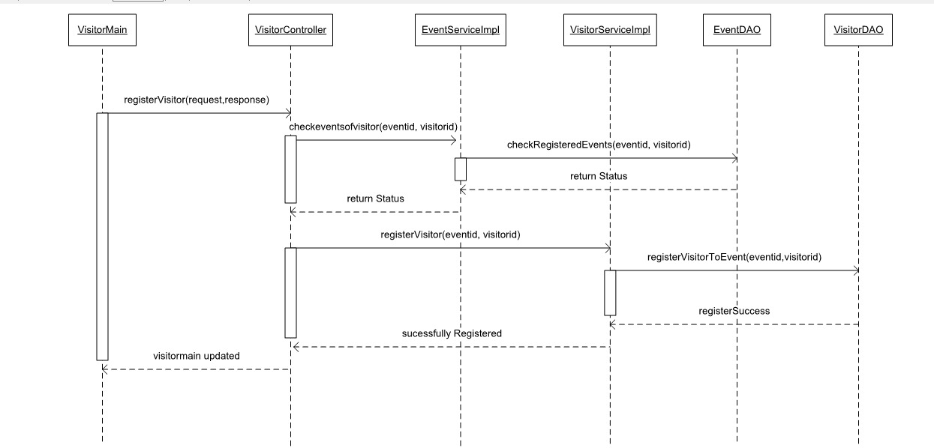

UNREGISTER FROM EXISTING EVENT

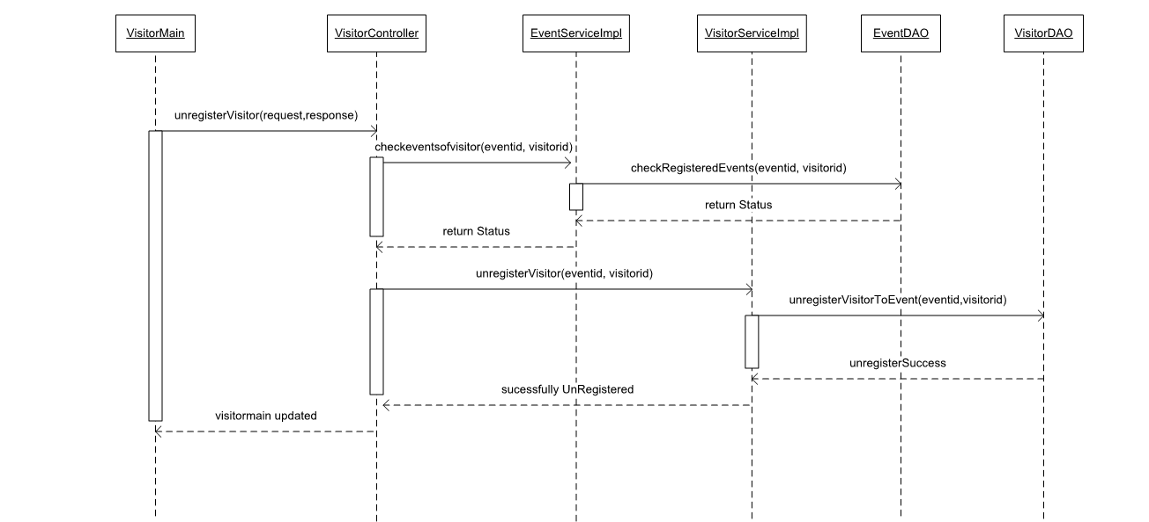

CONCLUSION

This software design specification is made with the purpose of outlining the software architecture and design of the Festival Event Registration System in detail. The document will provide developers an insight in meeting visitor’s needs efficiently and effectively. The Catalog Optimizer works perfectly and stores the Planning in accessible ways. Moreover the document facilitates communication and understanding of the system by providing several views of the system design.
It provides effective usage and visitors can frequently check about the events and ticket availability without facing any difficulties.

FUTURE WORK

The future work focuses on some database methods to automatically classify the details of the visitors based on unique id and other details provided by the visitor. And it also focuses on events can be processed and checked that can be postpone or cancel at anytime. In addition, we plan to extend events by considering other data such as visitor’s comments or concerns about the usage and ticket availability on the particular event registered by the user.

REFERENCES

- https://docs.spring.io/spring/docs/current/spring-framework-reference/index.html
- https://hibernate.org/orm/documentation/4.3.8/
- https://dev.mysql.com/doc/refman/8.0/en/
- https://www.w3schools.com/

